Lab 07 - IPv4 Network Address Translation (NAT)

What you will do:
- Using the skills and knowledge acquired in previous labs, you will build, configure, and test a Wired (Ethernet) network consisting of four nodes: two end devices (laptop) and two intermediary devices (Linksys router).
- Capture, analyze, and compare NATed and non-NATed traffic.
- Create a static routing table entry.
- Create a DMZ rule to expose a host to the Internet.
- Implement basic router configuration:
  - Connect to the router’s management web page. (Linksys router)
  - Modify the router’s IP address.
  - Disable and enable Network Address Translation (NAT)
  - Allow anonymous Internet requests.
  - Enable and assign the device to the DMZ.

Things that you will need to know or learn:
- Basic understanding of how NAT works.
- How to create a DMZ to expose a host to the internet

What you need to submit and when:
- Complete Lab 07 of the lab and demo it to your lab instrctor before the end of your lab period.

Required Equipment and tasks:
  - Network cables: two straight-through and one crossover
  - A partner
  - Two laptops
  - Two Linksys routers
  - Wireshark installed
  - Lab07-router1-config and router2-config – router 2 configuration instructions
  - Disable the Wireless Network Interface of your Laptop computer. Your only connection to the network must be via the Ethernet (wired) interface.

Task 0: Preparations
  - Do not start until you have completed ALL steps in this task.

Task 1: Build, Configure, and Test Network
In this task, you will build, configure, and verify the proper operation of the network topology shown in “Lab 07 – Network Topology”. The network you are building consists of three separate network segments: Network Segment 1, Network Segment 2, and Network Segment 3.
NOTE ABOUT YOUR TOPOLOGY DIAGRAM. THE IP ADDRESS ASSIGNMENTS SHOWN IN THE TOPOLOGY DIAGRAM WILL NOT TAKE EFFECT UNTIL AFTER YOU HAVE COMPLETED STEP 8. ONLY AFTER STEP 8 DO YOU FILL IN THE BLANKS OF THE TOPOLOGY DIAGRAM.
Do not start Task 1 until you have completed all Task 0 steps.
- Reset to factory default.
- Connect your laptop to any of your Linksys ports using the appropriate cable. One laptop per router!
- Connect the routers together via their respective Internet ports (yellow ports) using the appropriate cable.
- Confirm basic connectivity by making sure you can successfully ping your default gateway. Do an ipconfig to determine your default gateway address (at this point it should be 192.168.1.1)
- Write on the topology diagram who will be router 1 and who will be router 2.
- The IP addresses shown in your topology diagram will NOT be in effect until after you have performed the router configuration steps outlined in the next step.
- Perform the router configuration as per the router configuration document:
  - Refer to Lab07-router1-config if you are router 1.
  - Refer to Lab07-router2-config if you are router 2.
- Do not continue until all local and remote connectivity tests (ping) have succeeded!
- Install and test a Web Server (on only one of the laptops) as per the instructions in Lab 03 Task 2.
- At this point you should have a fully functional network where:
  - All connectivity tests succeed.
  - The web server is accessible from the web client. From the client computer open your browser and insert the server’s IP address with the port number. Example: 192.168.254.31:8088. You should see :
- Fill in the blanks in your topology diagram!
Client Address:172.16.254.1
Server Address: 192.168.254.31

Laptop 1 Laptop 2
IP address: 192.168.254. IP address: 172.16.254.
PC MAC: 38-F3-AB-68-26-B3 PC MAC: 7C-C2-C6-52-DE-AA
R1 (gateway) G0/0 MAC: C0:C1:C0:BC:67:2D R2(gateway) G0/0 MAC: 00:69:2A:74:26:8B
Role: web client or web server: web client Role: web client or web server: web server
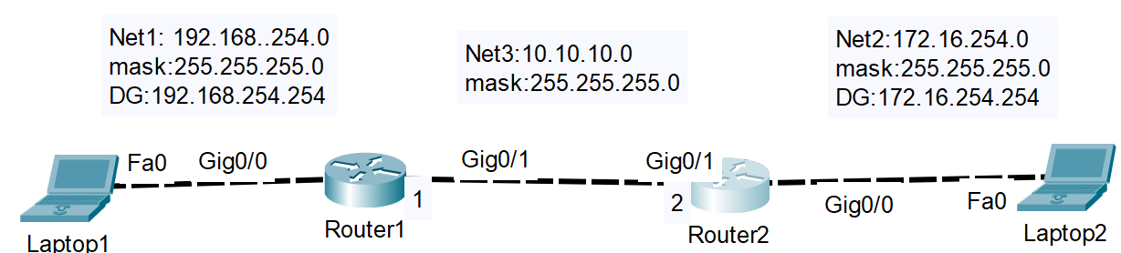

Task 2: Observe Non-NATed Network Traffic
In this task, you will capture non-NATed traffic.
- Both LAPTOPS need to capture the same HTTP traffic generated in this task!!
- Start your Wireshark capture (ON BOTH LAPTOPS) and apply the following filter!
http && tcp.port==8088 && ip.addr==w.x.y.z && ip.addr==a.b.c.d
where w.x.y.z is laptop’s 1 IP address and a.b.c.d is laptop’s 2 IP address.
- On the Web client laptop, open the web browser and enter the webserver IP address: 8088. The Web Server page MUST SUCCESSFULLY DISPLAY.
- The number of filtered frames MUST be identical on BOTH laptops!
- When step 3 is completed, stop, and save the capture on BOTH laptops.
  - Save as NonNAT-laptop1 if you are laptop 1 and NonNAT-laptop2 if you are laptop2.
- You will need both these Wireshark captures to perform your analysis and answer questions
- Task 3: Enable NAT and DMZ Security Feature
In this task, you will enable NAT on BOTH routers and the DMZ security feature on the web server router only.

On both routers (enable NAT)!
- Log in to the router’s management interface.
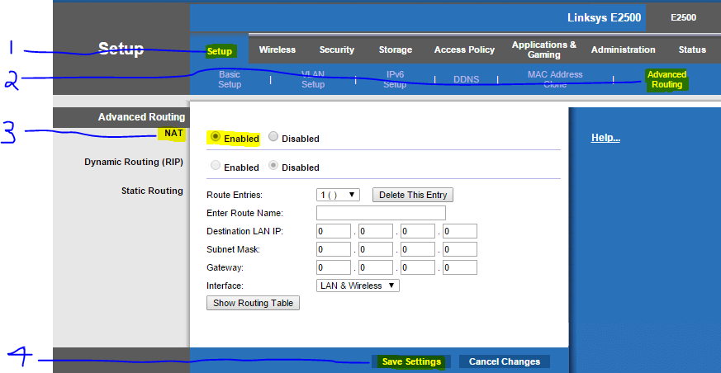
- Enable NAT on your router. Go to Setup Advanced RoutingNATEnabled save

On the web server router (enable Demilitarized Zone (DMZ))
Having enabled NAT in the previous step will result in the Web server no longer being directly accessible from the router’s Internet interface. Therefore, using the router’s DMZ security feature, you will allow the Web Server to be exposed to the internet as if it were directly connected.
- The following steps are ONLY to be performed on the Web server router.
- Log in to the router’s management interface.
- Enable the router’s DMZ feature and assign the Web Server to the DMZ as shown in the screen capture below. Go to SetupApplication & Gaming DMZ Enabled
- NOTE that you must specify the Web Server’s IP address in 6 below! (Example: 192.168.254.31 my IP address-server)
- Save Settings!
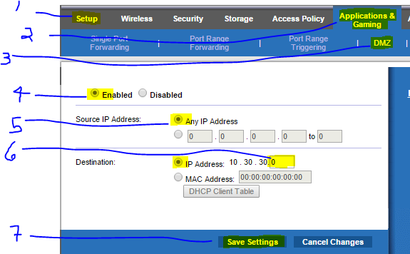

Task 4: Observe NATed Network Traffic
In this task, you will capture NATed traffic for later analysis.
- Both LAPTOPS need to capture the same HTTP traffic generated in this task!!
- Start your Wireshark capture (ON BOTH LAPTOPS) and apply the following filter!
http && tcp.port==8088
- On the Web client laptop, open the web browser and enter your partner’s Web Server address:port! (Server interface I: 10.101.10.1)The Web Server page MUST SUCCESSFULLY APPEAR.
  - REMEMBER THAT YOUR WEB SERVER IS SHIELDED BY A NAT ROUTER THEREFORE THE IP ADDRESS OF YOUR WEB SERVER TO REMOTE USERS IS THAT OF YOUR ROUTER’S INTERNET INTERFACE!
- The number of filtered frames MUST be identical on BOTH laptops!

  - Take a screen capture of the summary pane. Your capture must include the Filter field.
Screenshot here
    - Save as: sc1-NAT-laptop1 and sc1-NAT-laptop2 if you are laptop 2.
  - Both laptops need to save the screen captures!!!!
  - Note that the screen captures should be demoed to your lab instructor to show that you have correctly configured NAT and your DMZ settings. The following additional requirements must be met to get full marks. Two marks will be deducted per non-compliant requirement.
- On the web client’s screen capture, the server’s IP is 10.10.10.*. For example, on the client, the destination IP for the HTTP Get will be 10.10.10.* whereas the source will be the client’s true IP
- On the web server’s screen capture, the client’s IP is 10.10.10.*. For example, on the server, the source IP for the HTTP Get will be 10.10.10.* whereas the destination will be the server’s true IP
- When step 3 is completed, stop and save the capture on BOTH laptops.
  - Save as NAT-laptop1 and NAT-laptop2 if you are laptop2.

